Crate Training
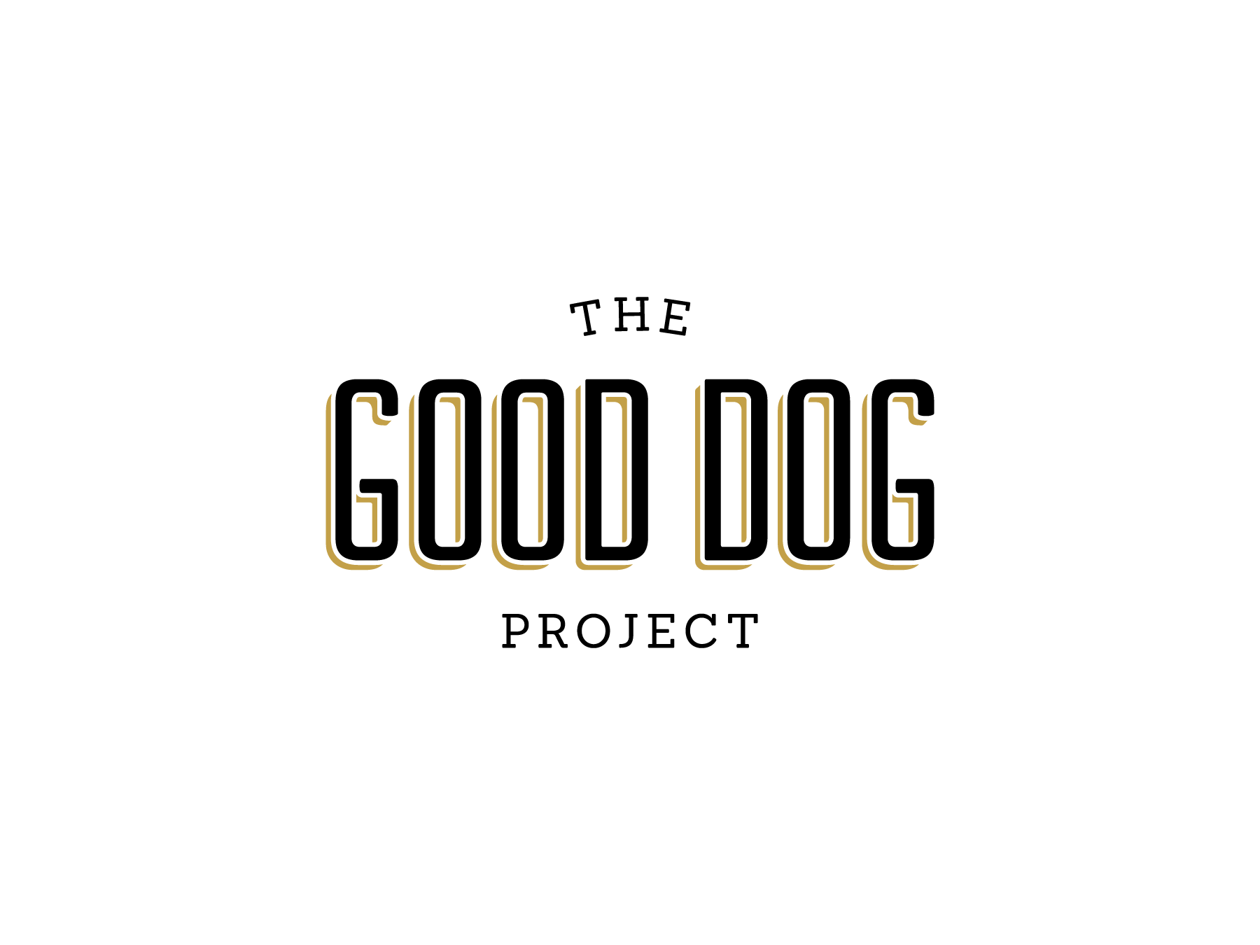
The crate can be a safe place for your dog to go relax and stay while you are away if introduced properly. While being crated, a dog can’t destroy your house or eliminate in places they shouldn’t. The crate can also create a safe retreat away from the hustle and bustle, and give them a place to call their own.
Choosing a Crate
When selecting a crate for your pet you should consider size and function. The size of the crate should be big enough for your dog to stand up, turn around and lay down comfortably. If the crate is too big your pet may be able to eliminate at one end and easily sleep at the other end. This would create a bad habit of crate soiling and weaken your dog’s natural genetic predisposition of keeping his living area clean.
The function of the crate is simply to provide confinement for your pet when he cannot be supervised. Crates come in two types, wire or plastic. Wire crates are easily moved around the house and provide the ability for the dog to be able to see what is going on around him. Plastic crates (transport type carriers) have solid sides and tend to be a little sturdier. Keep in mind if you are selecting a crate for your puppy that he is growing and may have to grow into his crate. You can use a larger crate and block space by using a divider but usually this is only achievable in wire kennels
Crate Placement
Now that you have the crate where do you put it? If crating your pet at night you will probably want to put the crate in your bedroom. Being close to you will help to relieve stress and make your pet feel more comfortable in his crate. You will also be able to hear if your puppy becomes restless. Very young puppies will have limited ability to hold their bladder or bowels and may need to go out in the middle of the night. If you are also crating your pet while you are at work or just out of the house the crate should be in a cool, dim lighted and quiet area (this helps to stimulate sleep cycles). You may even want to crate your pet occasionally when you are home, like when you are cooking dinner. In this case you should have the crate in the family area where your pet can see you so he is not isolated. Having more than one crate may be more convenient if you do not want to have to move the crate around. It is important that if you work from home or are home very often that you still utilize the crate if needed to teach a puppy or dog that having quiet time is okay. This can prevent later issues with separation anxiety.
Training
First impressions are important. When you begin all experiences between your dog and his crate must be positive and rewarding for him. Allow him to approach the crate to investigate, verbally praise your dog if he shows any interest in the crate and toss a few treats inside to entice him to enter on his own. The treats should be a high value item like freeze dried liver, a small bit of hot dog or cheese, something he is really going to like. Do not close the door at this point. Allow the dog to become accustom to the crate. Play with him with his favorite toy in or near the crate. Feed him his meals in or near the crate. Give him a special treat by placing it in the crate, like a stuffed KONG toy (or any hard chew toy you can stuff with something yummy). The important thing to remember is baby steps. Once your dog feels comfortable around the crate you can start to close the door and leave him in it for short periods of time. Use the special stuffed chew toy to encourage him to enter, leave the toy for him to enjoy and close the door. Only leave him in the crate for a few minutes and then let him out. It is important to only let your puppy or dog out of the crate when he is quiet. If you were to let them out right after barking or whining, they may learn that by barking or whining they get let out and will do this more and more.
Gradually increase the amount of time he is in the crate over a period of a few days. Always use the crate in a positive manner and never for punishment and do not abuse the crate by keeping your pet in it for long periods of time.
Now that you have a plan for introducing and using a crate here are some helpful tips and hints that will make crate training even easier.
- Some dogs and puppies will experience stress related to crate training and it is important to take it slow and not rush your pet.
- Never physically force your pet into the crate. This will cause a negative impression and possibly make your dog afraid of the crate. You could also cause injury to yourself or your pet.
- Try leaving a TV or radio on to make him feel less alone. This will also help to block out background noise that may stimulate your dog to bark or feel nervous. Play something soothing and not to loud.
- Covering a wire crate with a blanket will help create a cozier place when your pet is sleeping. This will also block his view from anything that may stimulate him to bark or feel nervous.
- Crate training may take days or even weeks remember to be patient.
- While training use a verbal cue or command such as “kennel up”. You will be able to use this later to ask your dog to go into his crate.
- Practice unemotional hellos and goodbyes when leaving your dog in the crate and upon returning. You want to keep it low key and not reward overly excited greetings or departures.
- If crating a puppy (overnight) he will probably need to eliminate sometime during the night. It is important to recognize if your dog or puppy is crying when in the crate because they need to go outside to eliminate. This may take a little time but you should be able to tell the different types of crying. “I want out of my crate” crying may be louder and more demanding. “I have to go to the bathroom” may be a whine or softer crying. You may also notice your dog becoming more restless and anxious if he has to go out.
- Caution should be used if you think your dog is suffering from separation anxiety. Using a crate could cause injury to your pet and may intensify his phobic behavior. You should consult your veterinarian if you think your dog has separation anxiety.
The Good Dog Project – www.gooddogproject.co - thegooddogproject@gmail.com

