Everyday Training made Easy
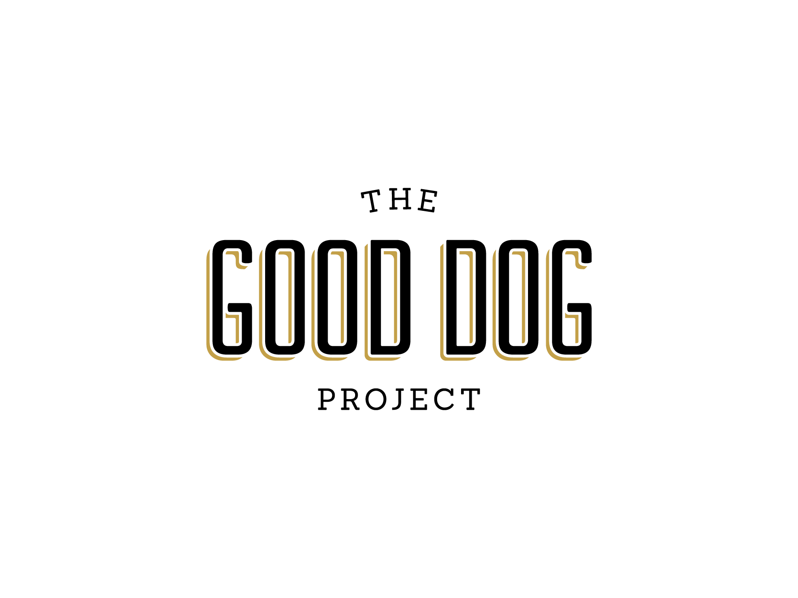
Wondering how to utilize basic obedience in your everyday life? By asking for behaviors a dog knows for a reward or resource in everyday life will help your dog become more polite and better behaved in your house. Resources are anything the dog wants or needs i.e.: treats, attention, petting, going outside, play time etc. This type of training is an excellent way to control a dog’s pushy or rowdy behavior and will also work to reinforce any basic training you have started.
Manage Your Environment
Setting expectations for your dog early on will help to prevent problems later but also allow your dog to practice desired behavior from the start. Your dog should know how to sit and lay down before you start this training. You will be asking for basic behaviors before rewarding your pet with resources. Start with the everyday resources your dog receives and then gradually build on that foundation. Add other cues for additional resources once your dog becomes acclimated to the process and make a game out of it. Other cues can be tricks such as “shake”, “roll over” or “speak”. Keep it interesting and fun. Examples of resources your dog may find important could be: a special toy or playtime, treats and attention or petting.
- If your dog brings you a toy and wants to play ask him to “sit”. Once he sits reinforce the behavior and say “good sit” and then “ok” (release cue), “let’s play”. Begin your play session.
- If your dog nudges your hand to be petted he is being pushy. Ignore his nudging and a few seconds later give him the “sit” cue. Once he sits you pet him and give him attention. (Rewarding for the sit and not the nudge)
- If you have a special time of day that your dog gets a treat (after dinner or when you get home or maybe before bedtime) you can use this opportunity to shape behaviors you like such as sitting or lying down. Before you give your dog his treat ask for “sit or “down”. Once he is sitting reinforce the behavior by saying “Good sit or down” and deliver the food treat.
- If your dog was waiting to be let out at the back door to have free time outside a great way to have them be more polite about their exit and entrance into the house is to have them sit or lay down or have them do one of their other cues to gain access to outside. This is a perfect example of a “life reward” They want outside but they need to do something for it and their reward isn’t treats or praise so much as just the release to the outdoors.
- A release cue is a word you will use to let your dog know it is ok to move or his task is over. A good release cue could be “all done” or “ok”. It is important to use a release when asking your dog to wait for something to happen and then letting him know he got it right and now he is free to go about his doggie business.
Tips and Hints
- Make sure your dog has learned the cue (“sit”, “down”) before you start this training.
- Start off with easy cues you know your dog will get right.
- Gradually add more cues for other things your dog wants (going for walks, playing with a favorite toy, getting on the couch).
- This type of training also takes into account “life rewards” and gives you the chance to use what your dog likes to do (play, go outside for a walk, get special attention from you) to reward him for good behavior. It’s not always about the food.
- Keep in mind this is not about making your dog work for everything in life and it is certainly not about “I’m bigger and stronger than you so I am the boss.” This training is built on mutual benefit and trust.
- Building an expectation of behaviors for your dog will help him make the right decisions.
- Take the guess work out of it for your dog. When you are giving him helpful feedback in the form of instruction and direction you create a less stressful environment for both of you.
The Good Dog Project – www.gooddogproject.co - thegooddogproject@gmail.com

