Multi Dog Households
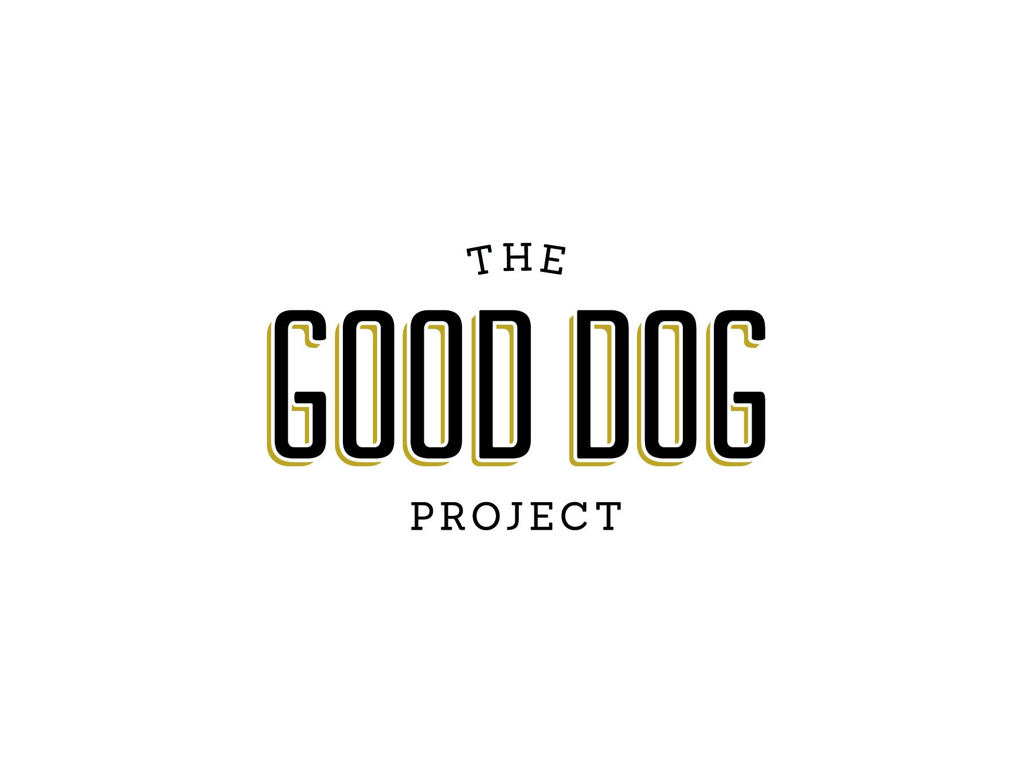
Managing a multi-dog household can be a challenge and the more dogs you have in an average size living environment the more difficult it may be. Dogs have a need for a surprisingly large area of living space in order to be mentally and emotionally content. Common problems with multiple dogs may be aggression between dogs, having accidents in the house or difficulty house training, or a pet that is fearful and constantly hiding.
Managing Your Environment
Dividing the real estate in your home will be very important in managing your dog’s environment. Each one of your pets should have his own feeding area, resting area and toys. If your dog does not have to share his resources he will be less likely to become territorial or competitive. If your pets are sharing toys and areas nicely then if it is “not broke don’t fix it”. Some dogs are naturally more territorial than others and predicting which dogs or how many dogs will get along with each other is impossible.
Taking your time when introducing a new pet is critical. You should never force dogs in your household to interact with each other. Let them proceed at their own pace. A spare bedroom or family room that can be closed off will work great as a safe place for your pet if they have to be separated temporarily. Successful acclimation can sometimes take weeks and even months. Providing an interactive and entertaining environment for your dog will help to decrease boredom and stimulate exercise. Dogs that are mentally and physically satisfied will feel less compelled to search for entertainment and you will find that they are getting into less trouble.
Correcting Mistakes
If you have dogs that are fighting on a regular basis the most important thing is to manage the environment in order to eliminate the fights. Fights that are allowed to continue will only get worse. Dogs that fight learn this behavior and will use it more quickly in order to deal with conflicts. Don’t let it become a habit! Your pets should not be left to “work it out on their own.” Separating dogs into different areas of the house while working on modifying the behavior will be helpful. This will lower the level of tension and help your pets feel safer and less threatened. Several hours to several days of separation may be necessary depending on the severity of the aggression between dogs. Slow and gradual exposure and re-introductions are needed when attempting to bring dogs back together in the same area. Positive reinforcement with food treats and verbal praise when dogs are interacting appropriately will help to make it a pleasant and less frightening experience. You should never force any physical contact; let them get reacquainted at their own pace. Dogs that have a history of fighting with each other may never become best friends, and may just tolerate each other. Some highly territorial dogs may do better as the only dog in the household.
Avoiding the Pitfalls
You should never punish your dogs for fighting or use punishment to interrupt aggressive behaviors. Punishment in most cases will only elicit an increase in aggression or fear and you may become the indirect target of a bite or a scratch. Redirect your dog when you see one of them targeting another dog in the house (stalking, standing over, or starring) and get his attention focused on something else, such as a favorite toy or a food treat. Learn your dog’s body language and try to anticipate when aggression might develop between your pets. Avoid activities that may trigger aggressive responses in your pets. It may take some detective work to uncover your pet’s sensitivities and to discover what is most likely to trigger an event. Stopping fights before they get started will help to decompress tension in a household where dogs are not getting along. If a fight has already begun it is important to interrupt it as soon as possible. Use a loud clap of your hands or a loud “HEY”. Often dogs that are in fight response are difficult to separate; you may need to have a spray bottle of water or a can of compressed air to use as an interruption by spraying them. Do not attempt to pick up or separate your dogs with your hands or feet as this could easily result in an injury to yourself. Once separated your dogs should be isolated from each other in order to calm them down. It may take some time for your pet’s mental and physical state to return to normal so be patient and do not rush to put them back together until you are certain immediate fighting will not reoccur.
Tips and Hints
There are a lot of variables that determine whether dogs in your house will be friends or foes, many of them not fully understood even by the most experienced professionals. Socialization does play a big role; puppies that have been exposed to other dogs at an early age or come from friendly parents are more likely to be tolerant or friendly towards other dogs.
- Considering a trip to your vet for extreme cases may be helpful. Your vet may be able to provide medication to help your dog thru the training and behavior modification period. It is also important to ensure your dog’s issues are not related to any medical condition prior to starting a behavior modification plan.
- Spaying and neutering your pets is important in creating a well balanced multi- dog household. Just one intact member may cause problems in the entire group.
- Establishing predictable routines in the household and eliminating or minimizing stressful events, (such as planning a big party or having company stay over) during training and behavior modification periods will make learning easier for your pet and positive results more attainable.
- Small spaces can cause elevated tension (hallways, doorways, more than one dog confined to a small room) so make sure each dog has enough personal space to be comfortable.
- Exercise can help to reduce stress. Find an activity your dogs enjoy and take time to play a fun game with them.
The Good Dog Project- Thegooddogproject@gmail.com - www.gooddogproject.co

