House Training
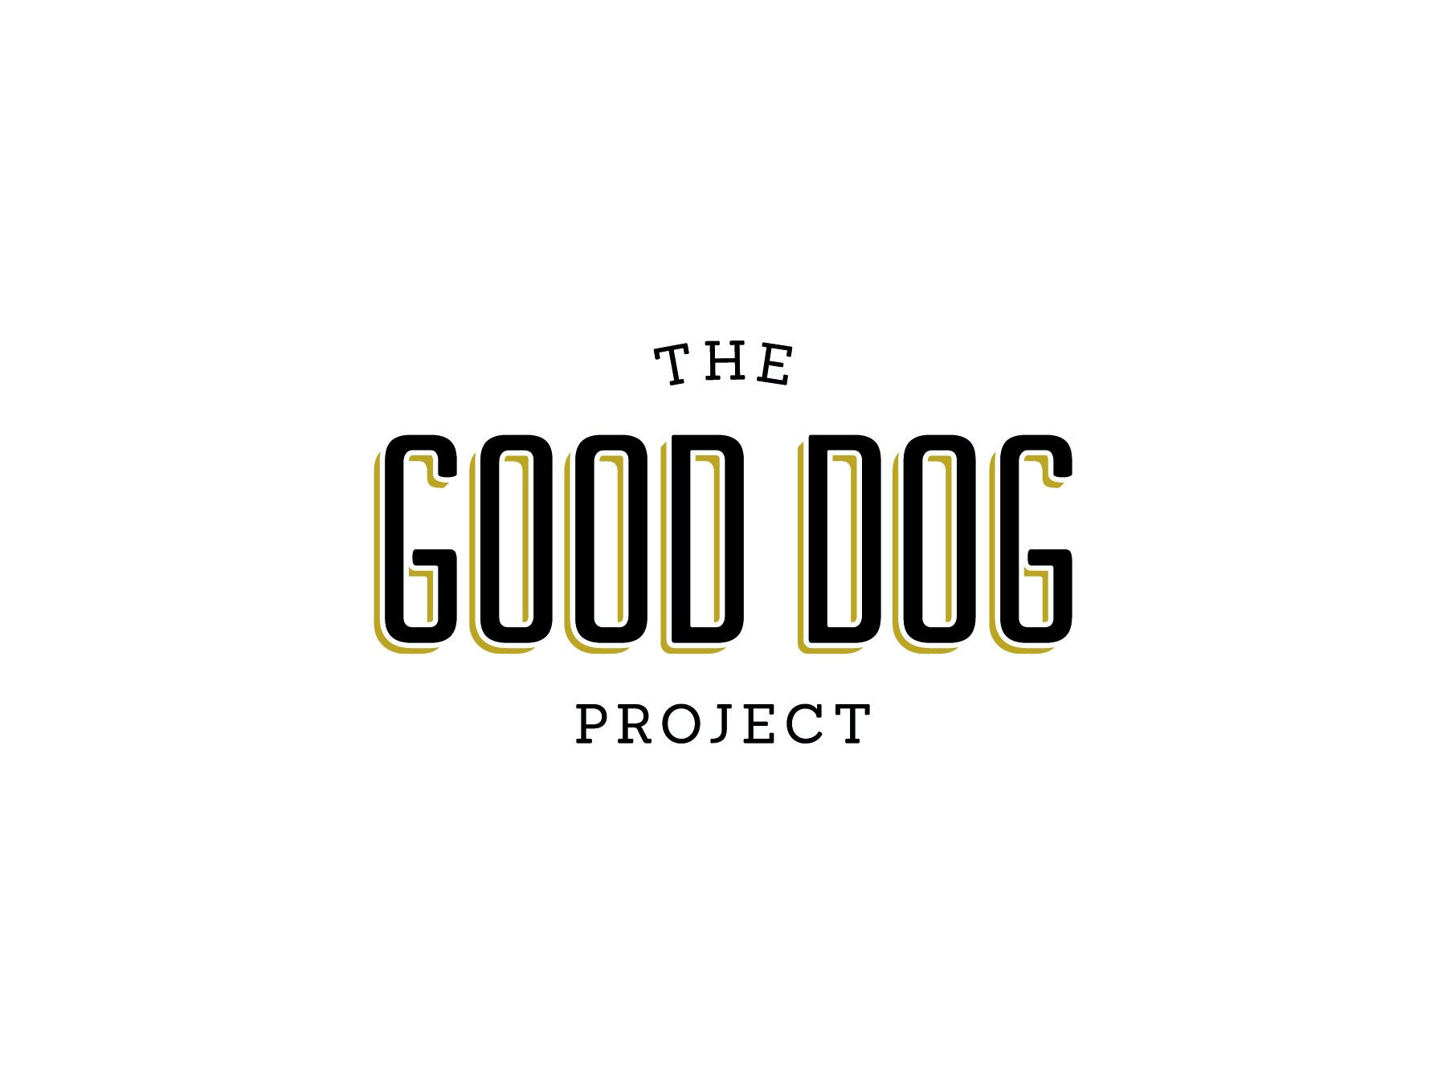
House training your pet may be one of the most important things that he learns. Starting off on the right foot is very important, decide what your goals are going to be with house training from the very first day and work towards that goal together. If given a choice your puppy may make mistakes and have accidents and this is a pitfall we want to avoid. If allowed to make mistakes routinely your pet will soon develop a habit and training will be frustrating and confusing for him. The goal is usually simple...you want your pet to readily and consistently eliminate outside and we can get that done in eight easy steps!
- SUPERVISION - Supervising your pet is critical to the success of house training. When your pet cannot be 100% supervised then he should be in a long term confinement area (like a kitchen with a baby gate) or his crate. Another good way to keep your pet close to you is to use a leash that can be hooked to your belt loop or around your waist, this method may not work for everyone but can be considered an option. Keeping an eye on things helps to eliminate accidents and will make house training quick and easy.
- ELIMINATE ACCIDENTS – You can easily eliminate accidents by supervising your pet and supervision while in the home will also help to curtail other behavior problems like chewing inappropriate items. Eliminating accidents is important to keep your pet from developing bad habits. If allowed to routinely make mistakes house training will take longer and be more frustrating for you and your pet.
- DEVELOP A ROUTINE – Dogs thrive on and come to expect routine in their lives. Developing a routine when it comes to feeding and eliminating will set a schedule and start a good habit. Meals should not be free fed but should be fed around the same time each day (three times a day for puppies and twice a day for adults). Vary feeding times to reduce stress and expectation behaviors in your pet. Feeding in the morning and then again in the evening for adult dogs (but not at exactly the same time everyday) will create better behaviors in your pet’s routine. Once the food is put down allow 10 to 15 minutes for him to eat and then whatever is left pick up. It will be much easier to predict what time it has to come out if you know exactly what time it when in. The routine should also include going outside to eliminate and the general expectation for when a dog will have to go is: 30 minutes or so after eating or drinking, when he wakes up (even from a nap) and after play, activity or exercise.
- ELIMINATE ON COMMAND – Sounds impossible but it is a very important part of the plan. When your pet is outside he should always be accompanied by you and be on lead. A cue or command should be used.....hurry, hurry, go potty, or whatever you choose as long as it is the same cue each time. Select an area of the yard to be the bathroom and stay in that spot. Walking around and smelling the flowers can be a source of distraction to your pet.
- 5. REWARD – Now comes the reward. When your puppy goes (and he will) verbally praise him and offer a food treat. The food reward should be a high value item like a small piece of cheese, hot dog or freeze dried liver. The treat needs to be delivered quickly after elimination (within 3 seconds) in order to positively reinforce that behavior. Note: be careful verbal praise is not too exciting and interrupts elimination.
6. BE CONSISTENT – Continue your training daily and do not skip a day because you get busy or it is raining outside. Do not vary the routine or change the command. Changes or lapses in training will be confusing for your pet and house training will take longer. Stick to the plan. Most puppies will need at least 21 days straight without any accidents to have training solidly in place and you may want to push that to 30 days just in case you may have missed an unknown accident. Some remedial training may be necessary if the puppy is stressed or the routine changes.
7. ELIMINATE PUNISHMENT – It just does not work! Punishing your pet after the fact may even damage your emotional bond and he may become afraid of you or afraid to eliminate in front of you. If you catch your puppy in the act interrupt him by just picking him up. Remember to lose the upset attitude about having caught your puppy making a mistake and use an up beat voice “you want to go outside” and immediately take the puppy outside. Praise him and offer a food reward when he eliminates outside.
8. CLEAN UP – This step is very important. Odors left on carpet or the floor are like a big red flag saying “go here, go here!” Always use an enzyme cleaner to get rid of odors and stains. Most cleaners can be found at a local pet store, your veterinarian or here at the humane society’s pet boutique.
Now that you have a plan in place here are some helpful tips and hints that will make training even easier.
- • If you do not have a yard and walk your pet to eliminate remember to still pick a bathroom spot. Dogs like going for walks and if the walk is over as soon as they go to the bathroom then they will likely hold out as long as they can in order to extend the walk, often not eliminating completely, if at all. Use the bathroom spot first and offer a food reward and then your pet gets a double whammy reward by going for a walk.
- • Some people try to cut corners by waiting at the back door with a treat for their pet and once they come inside then they get the treat. From the dog’s point of view you have just rewarded him for coming back to the door and coming in and not for eliminating outside at all. It is important to be with your pet in the yard and deliver the treat with in 3 seconds of the desired behavior.
- • Giving plenty of opportunities to a new puppy to go outside is critical. You would be amazed at how many times a puppy can actually have to go! The frequency can be reduced as your puppy gets older.
- • A general rule of thumb for puppies when house training or crate training is that they can only hold it about one hour for every month they are old plus one. So if you have a 3 month old puppy he will only be able to hold it for about 4 hours. As your puppy gets older his bladder and bowel control will increase.
- • Keep in mind if you have a tea cup or a miniature breed pet they are very small and their organs inside are small too. The ability for them to hold it for extended periods of time is very limited and they will need to eliminate frequently simply because they are too small to hold too much.
- • If problems occur and accidents are difficult to overcome it is important to ensure of clean bill of health and a trip to your veterinarian may be in order to rule out any existing medical problems.
- • Patience, patience, patience.
The Good Dog Project – www.gooddogproject.co - thegooddogproject@gmail.com

